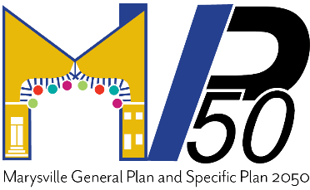
Agenda
General Plan Advisory Committee
City of Marysville
Wednesday October 18, 2023
6 p.m. Council Chambers
526 C Street

- Agenda
- Call Meeting to Order
- Roll Call/Sign in Sheet
- Recap of Advisory Committee work to date
- Presentation – Summary of Working Draft Land Use + Community Development Element
- Advisory Committee Questions, Comments, and Suggestions
- Presentation – Summary of Working Draft Circulation Element
- Advisory Committee Questions, Comments, and Suggestions
- Closing

- Public Comment
This section is intended to provide members of the public with the opportunity to comment on any subject pertaining to the General Plan. This section is limited to 20 minutes. Each speaker will be afforded three minutes to address the Committee. Each speaker will be permitted to speak only once. Written requests, if any, will be considered first under this section.

- Adjournment
Any writings or documents provided to the General Plan Advisory Committee regarding any item on this agenda shall be submitted to staff for review and distribution to the GPAC as appropriate. Said writings or documents will be retained as required by public records retention laws. It is the intention of the City of Marysville to comply with the Americans with Disabilities Act (ADA) in all respects. If, as an attendee or a participant at this meeting you will need special assistance beyond what is normally provided, the city will attempt to accommodate you in every reasonable manner. Please contact the Community Development Department at (530) 749-3941 at least forty-eight (48) hours prior to the meeting to inform us of your particular needs and to determine if accommodation is feasible. Please advise us at that time if you will need accommodations to attend or participate in meetings on a regular basis. An agenda packet is available 24 hours at www.marysville.ca.us under the Planning Division and during City Hall hours and information can be found at General Plan Update | City of Marysville.

